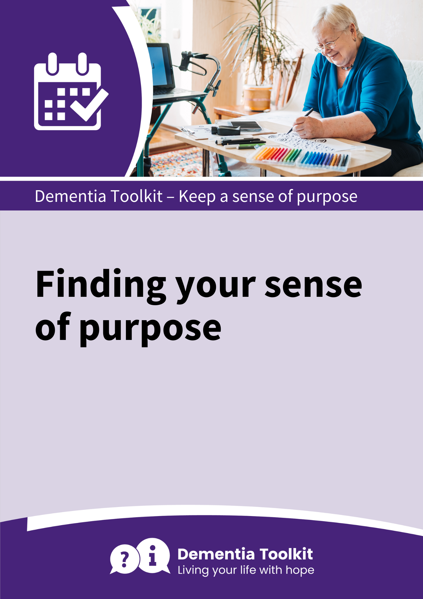

What or who is important to me?

What interests me?

What time do I have?

How practical is it?

Doing a regular task or activity can provide a sense of purpose
But what shall I do?
How much support or help do I want?

What skills do I have?

Some ideas of regular activities or tasks I would like to do:



