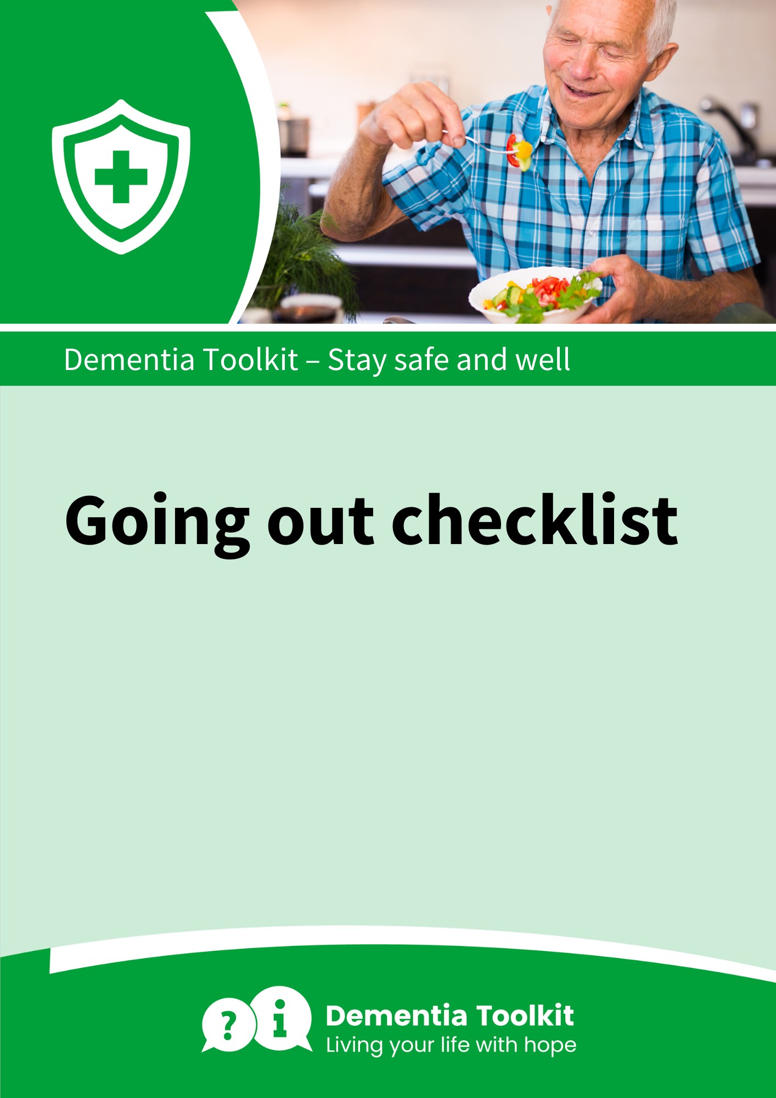

Going Out Checklist
You can edit this to suit your needs, then print it out and stick it up by the door as a handy reminder. We have left some blank spaces for you to add in your own items, such as reading glasses or a walking stick.

1. | Keys  
2. | Purse or wallet – (some shops are only taking card payments because of COVID-19)  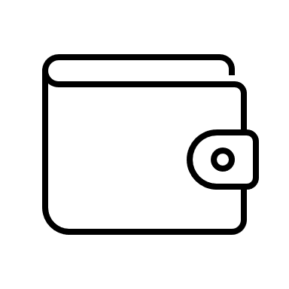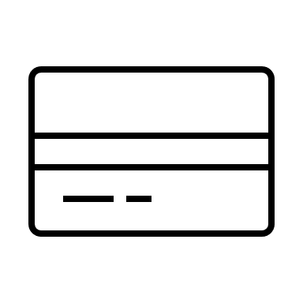
3. | Mobile phone  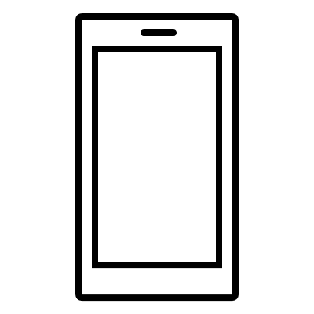
4. | Face mask or sunflower lanyard  